**Generating a Sitemap using Microsoft Visio**

Search for a ‘site map’ template:

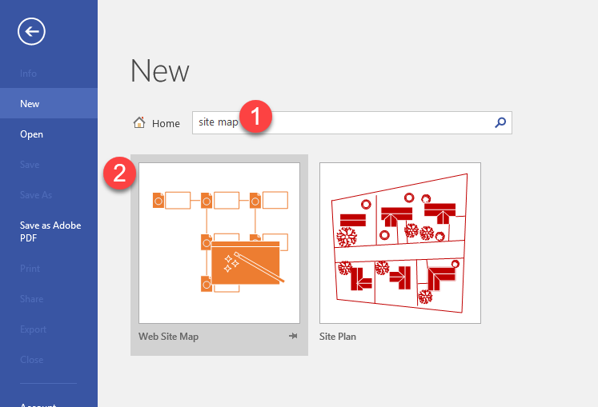

Click on Create

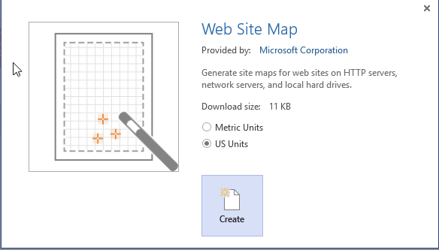

Enter your website URL and click on OK.

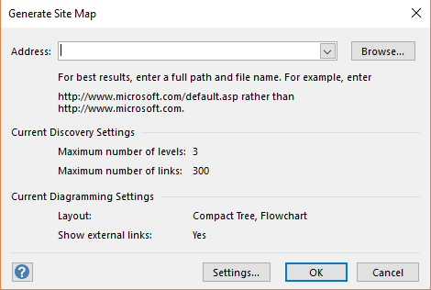

The site mape will begin to generate.

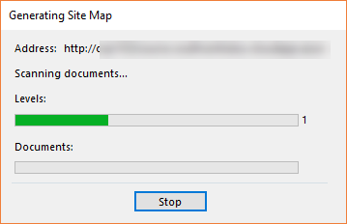

Depending on the size and number of pages of your site, you’ll then see a map with branches generated.

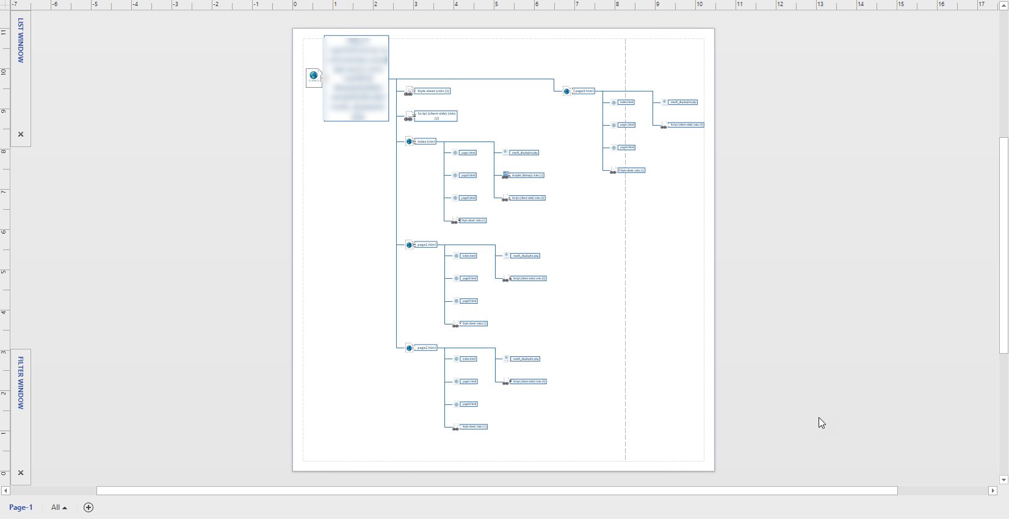

To save your site map, click on File >> Save As. You may save it as a JPG or PDF.

